Assignment -5

**Course Name:** Computer Science Fundamentals & Career Pathways

**Name**: Pranav Nailwal

**Section**: B

**Step 1**

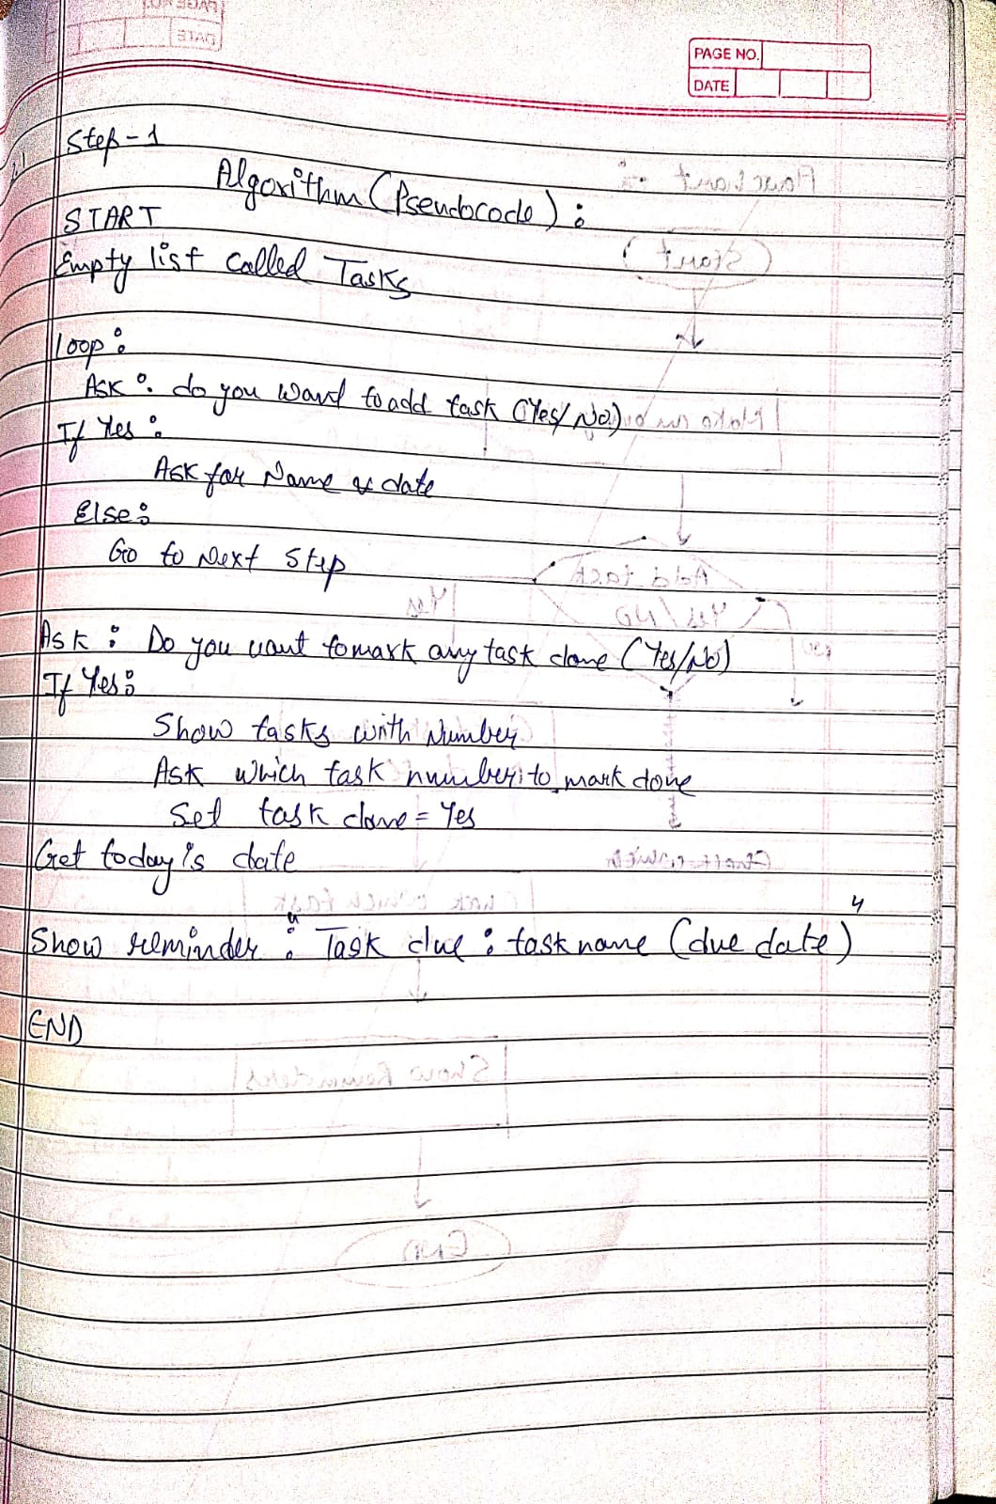

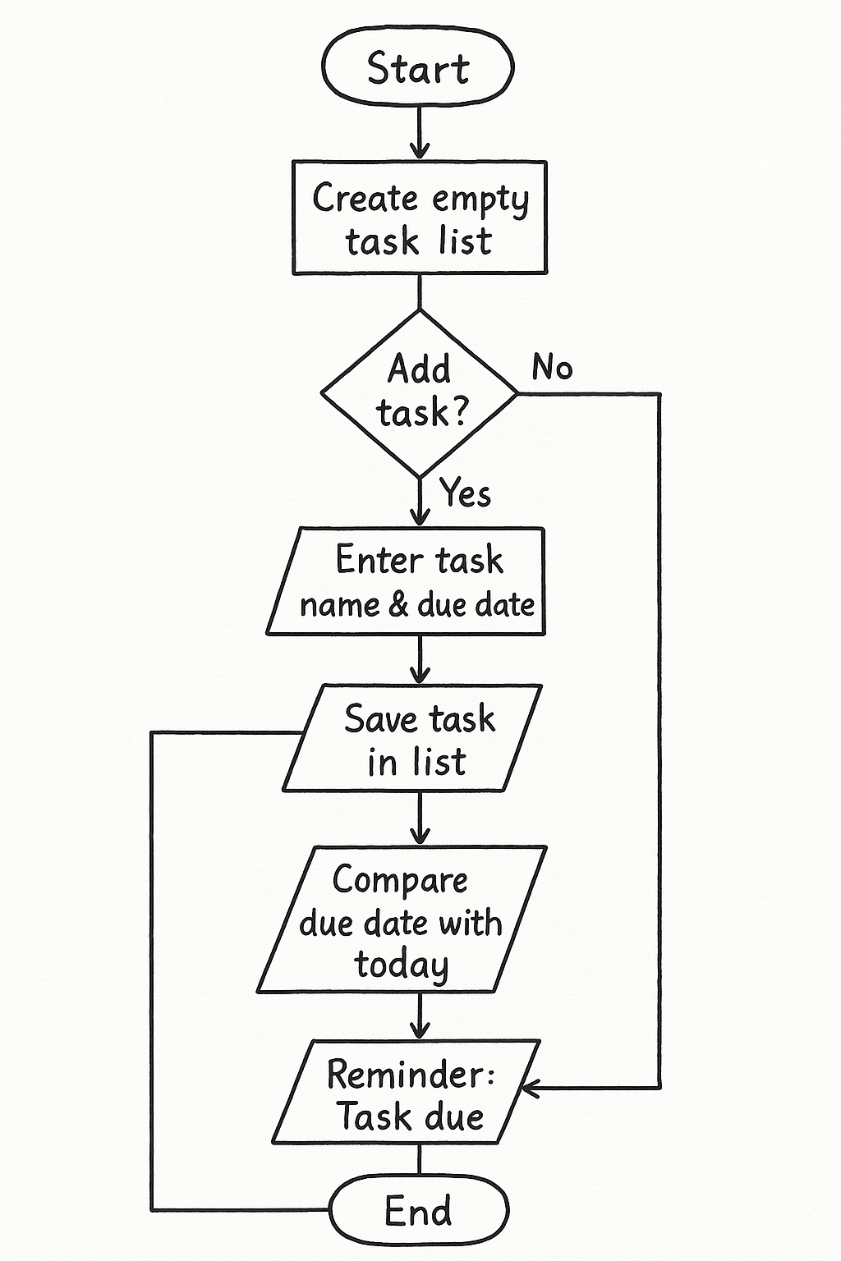

**Step 2**

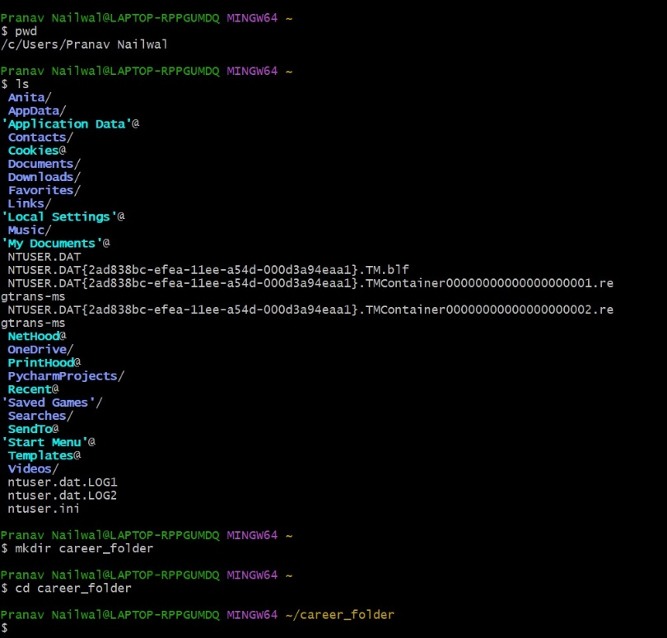

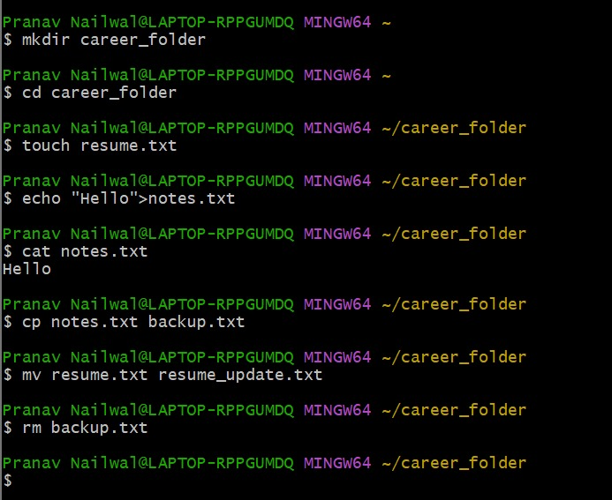

**Step 3**

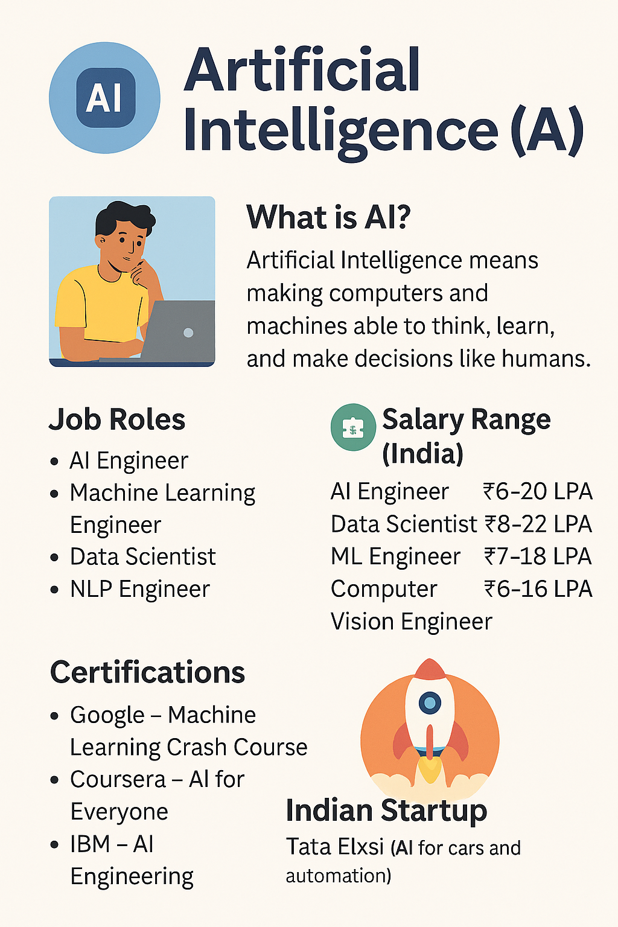

**Step 4**

My long-term aim is to build a strong career in the field of Artificial Intelligence and Machine Learning. I have always been curious about how technology works behind the scenes and how machines are able to learn and perform tasks. This interest is the main reason why I want to move forward in AI and ML. I know that building a career in this field requires strong basic skills, coding knowledge, confidence, and practical experience. So, my career roadmap focuses on learning the basics first, improving my skills, and slowly moving toward advanced areas.

In the first year of my B.Tech journey, my main focus is on learning Python and Java properly. These two languages are used a lot in AI and other computer science fields. Along with this, I also want to work on improving my communication skills, because communication is important everywhere—whether it is interviews, team projects, or presentations. Once I complete these basics, I will be in a better position to learn advanced concepts.

In the next 6–12 months, my goal is to start learning the basics of machine learning. I plan to use beginner-friendly courses like the Google Machine Learning Crash Course to understand simple ML models and how they work. During this period, I also want to participate in hackathons. Hackathons give real experience and help me understand how to work with a team, how to manage time, and how to think creatively under pressure. I believe joining hackathons will improve my confidence and give me practical exposure.

By the time I reach my second and third year, I want to start building small AI and ML projects. These projects will help me apply whatever I learn. I also want to keep improving my coding, communication, and consistency. Along with Python and Java, I want to slowly improve my skills in libraries like NumPy, Pandas, and basic ML models. I also plan to complete certifications such as AWS Cloud Practitioner, because cloud knowledge is very helpful for AI engineers.

My long-term roadmap includes gaining internships. I want to aim for AI and ML-related internships from my third year onwards. Internships will help me understand how the industry works and what kind of skills companies expect. Working with real teams will also increase my confidence and help me improve my teamwork and problem-solving abilities. I want to learn how AI models are built and used in real-world applications.

Throughout this journey, my strengths—such as creativity and curiosity—will help me stay motivated. I enjoy building things, trying new ideas, and exploring concepts. I also want to continue improving my communication and coding because these are important for any career in technology. My overall aim is to become a skilled AI engineer who can work on meaningful projects and contribute to the field of technology in the future.

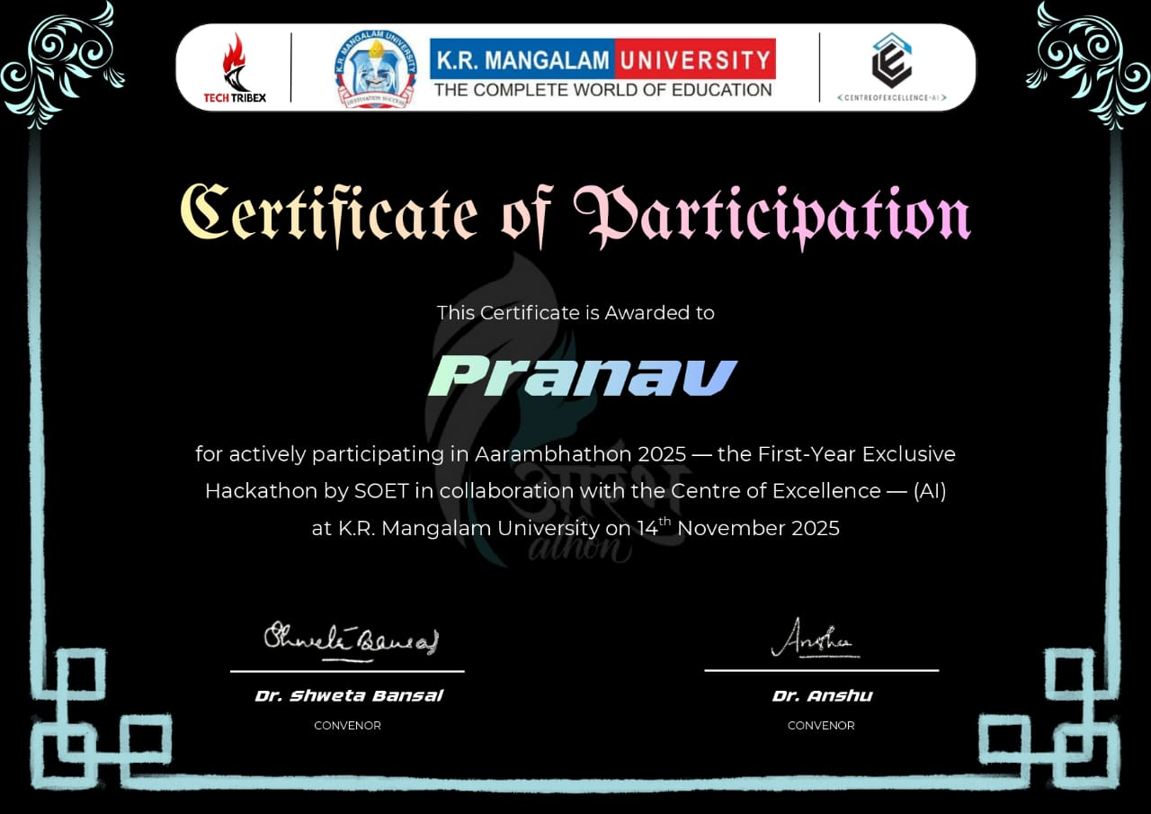

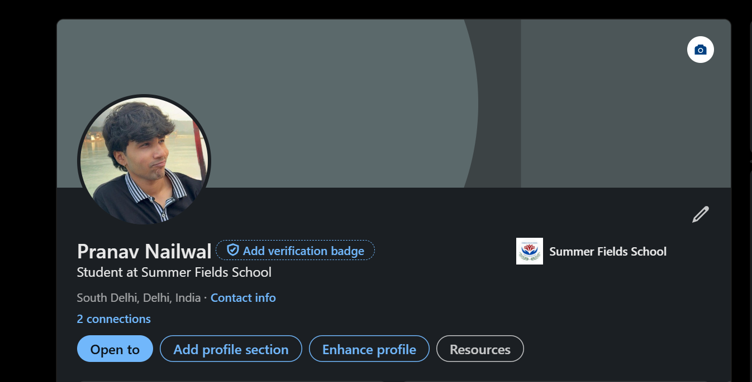

**Linked in profile link:** <https://www.linkedin.com/in/pranav-n-33395030b/>

**Step 5: Reflection**

This assignment helped me learn many new things about planning my career and improving my technical skills. While working on the Linux commands, I learned how to manage files and create basic scripts, which I had never done before. Designing the algorithm and flowchart also improved my understanding of computational thinking. The infographic and career roadmap made me think seriously about the field I want to enter and the steps I need to take to reach my goals.

I also realized how important it is to stay consistent, keep improving communication skills, and build projects regularly. Registering for a hackathon motivated me to work on teamwork and problem-solving. Overall, this assignment gave me a clear vision of what I need to work on in the coming months and how to shape my long-term career in AI and ML. I feel more organized and confident after completing this work.